Kevin Harrington meets famous Indian music director Shekhar Ravjiani at a concert in Atlanta.

Famous Indian music directing duo known as Vishal-Shekhar has just finished the US tour. The duo performed live in twelve cities around the US, and the massive tour was put on by Patel Brothers grocery and spices stores chain which is also based in the US.
The Vishal-Shekhar music duo consists of Shekhar Ravjiani and Vishal Dadlani, and they released their first album in 1999, and since 2003 they have been successfully making music for Bollywood produced movies, so they are well-known in India. The US tour had a massive response and was positively criticized by fans.
During the duo’s concert in Atlanta Kevin Harrington was asked to climb up on stage by Ravjiani. When he appeared on the stage he was greeted with a huge applause. As you can see on a recently released video, Kevin also received a bouquet of flowers as a gesture of gratitude for his cooperation with the Patel Brothers chain of stores. Kevin was moved by this event and together with Ravjiani thanked the audience from the stage.

Kevin has also used this opportunity to support the famous reality television series Shark Tank, which started airing in India at the beginning of 2016.
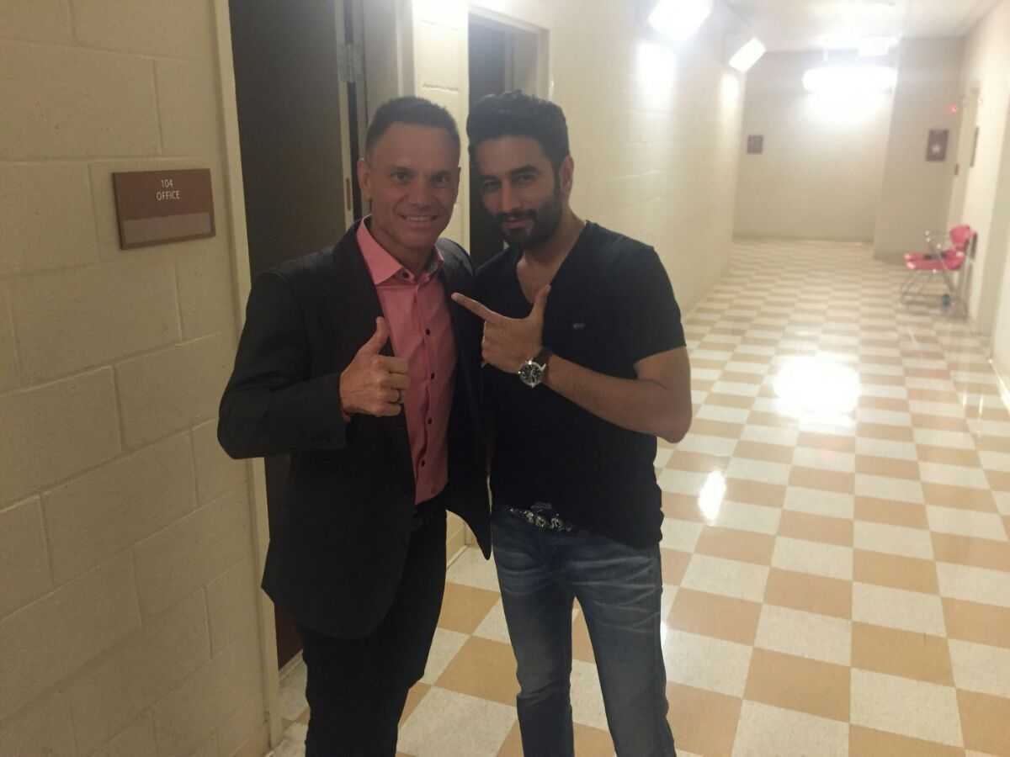
After the concert Kevin and Ravjiani met back-stage, where photographs took their photos together and discussed each other’s future prospects and some possible future joint cooperation about the publicity of Shark Tank in India.
Kevin Harrington expressed special gratitude to Shekhan Ravjiani, on a great performance and a friendly talk after the concert.
Colors Infinity program has launched a massive marketing campaign for reality series ‘Shark Tank‘in India. At the moment they are searching both investors and entrepreneur contestants. Will Shark Tank series have the same response and success in India as it has in the USA. We can safely say that all that depends on how well will the Colors Infinity (English entertainment channel) carry out their promotional campaign. We can also say that the appearance of Kevin Harrington on Shark Tank India will generate more popularity for this show.
You can find a new Facebook page “Shark Tank India”, there you can discuss about different subjects. Who should be in the panel for Shark Tank India?
Airing time of Shark Tank on Colors Infinity is 9 PM during the weekdays. However you can also watch repeated shows during weekdays at 2 am, 9 am, 2 pm, 5pm or Sundays at 3pm to 7pm.
We are left to ask will this newly formed friendship result in boosting India’s new talents and inventors, will Kevin Harrington’s Midas touch combined with Shekhan Ravjiani’s musical ingenuity in some way affect India and its people in a positive and encouraging manner.

